FACULTY EVALUATION
Programme Name: Social Entrepreneurship Development Program (SEDP)- Advance Tanzania (2nd February - 6th February 2026)
Session: Governance and succession planning
Faculty Name: Dr. Freshia Wangari Mugo-Waweru
No. of Respondents: 20
No. of Participants: 20
Evaluation Parameter | (%) Individual Score | (%) Programme Average
Punctuality (Commencement and Completion of Sessions) | 96 | 95
How well do you understand the core concepts presented? | 98 | 90
Rate your confidence in applying the new skills learnt | 95 | 91
Degree of Faculty preparedness for the sessions | 98 | 94
Content and methodology of the program | 98 | 94
Quality of class and group discussions | 100 | 92
The information presented in the course is relevant to my work (ministry) | 99 | 94
Average scores | 98 | 93

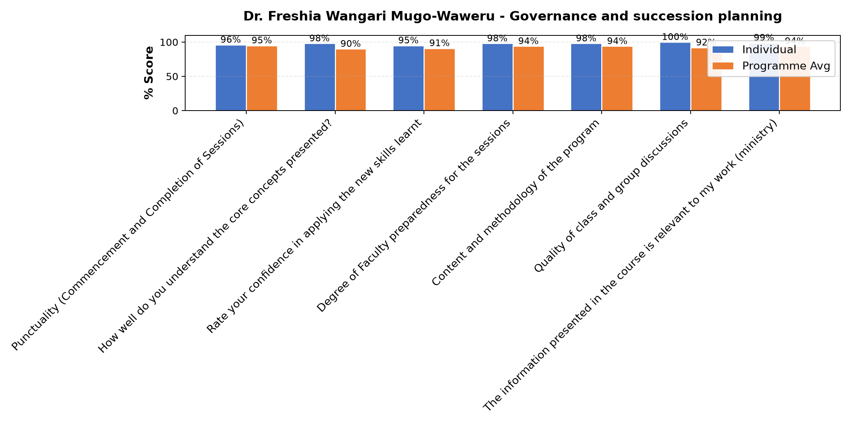

Comments & Feedback
- • Ni mwalimu mzuri sana
- • Mbunifu anawapa wanafunzi motisha.
- • Mwalimu ameeleweka vizuri sanaa
- • Nimejifunza mambo yafutayo.
- • a.mwelekeo wakimkakati
- • b.rasimali inatakiwa iweje.
- • c.usimamizi na uangalizi.
- • d.majukumu ya bodi kwa ufanisi.
- • e.majukumu na wajibu.
- • Nothing,
- • May be lacking commitments
- • No burriers
- • Namna ya kuwa kiongozi Bora
- • Excellent
- • Ni kubadili mitazamo ya wale walionitangulia na wenye uzoefu wa kazi kuhusu kubadili baadhi ya sehemu ambazo nimejifunza kwa ajili ya kuboresha taasisi zetu
- • Nil
- • Nothing
- • Kikwazo vinavyoweza kujizuia kutumia vizuri elimu hiyo miliyofundiswa. Kuna ushindani wa ile biashara yangu. Matumizi sahihi ya IT ukosefu wa vifaa vya kisasa kuendana mabadiliko ya ulimwengu wa sayansi na teknologia n.k
- • Only lacking commitment
SUBMITTED THROUGH:
SBS Evaluation Automation System

